**DAILY ONLINE ACTIVITIES SUMMARY**

|  |  |  |  |  |  |  |  |
| --- | --- | --- | --- | --- | --- | --- | --- |
| **Date:** | **23/05/2020** | | | | **Name:** | **AMBIKA V** | |
| **Sem & Sec** | **4th SEM 'A' Section** | | | | **USN:** | **4AL18CS005** | |
| **Online Test Summary** | | | | | | | |
| **Subject** | | **Data Communication** | | | | | |
| **Max. Marks** | | **30** | | **Score** | | **23** | |
| **Certification Course Summary** | | | | | | | |
| **Course** | **CLOUD FOUNDATION and PYTHON WORKSHOP FOR BEGINEERS** | | | | | | |
| **Certificate Provider** | | | **greatlearning academy** | **Duration** | | | **4.5 hours** |
| **Coding Challenges** | | | | | | | |
| **Problem statement** 1: Write a C or Java program to implement round robin type of process scheduling. | | | | | | | |
| **Status: completed** | | | | | | | |
| **Uploaded the report in Github** | | | | **yes** | | | |
| **If yes Repository name** | | | | **https://github.com/ambika0202/lockdown-coding-** | | | |
| **Uploaded the report in slack** | | | | **yes** | | | |

**Online Test Details:**

The online test was from module 1and 2 which was about the Introduction to Data Communication, Networks models, Introduction to Physical Layer-1, Digital Transmission, Physical Layer-2. There were 30 questions and the duration was 40 minutes. The questions were optimal and were easy. The score that I got in the test is 23/30.

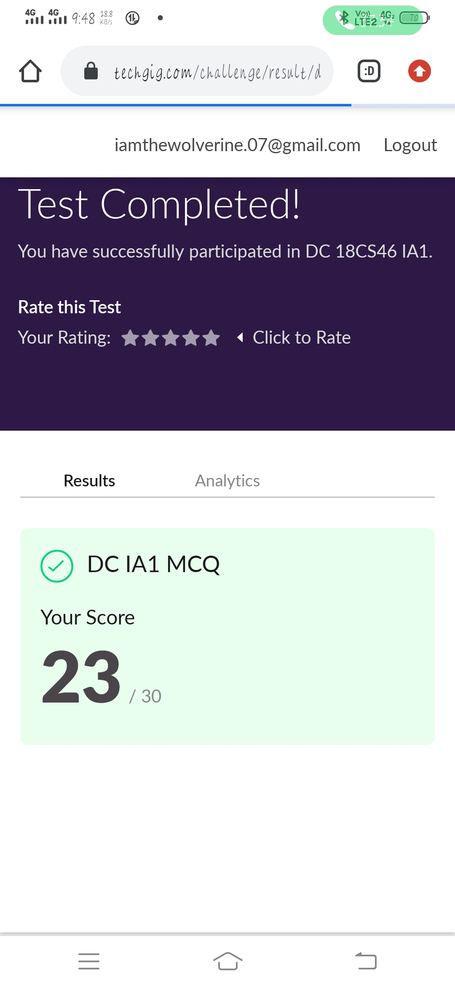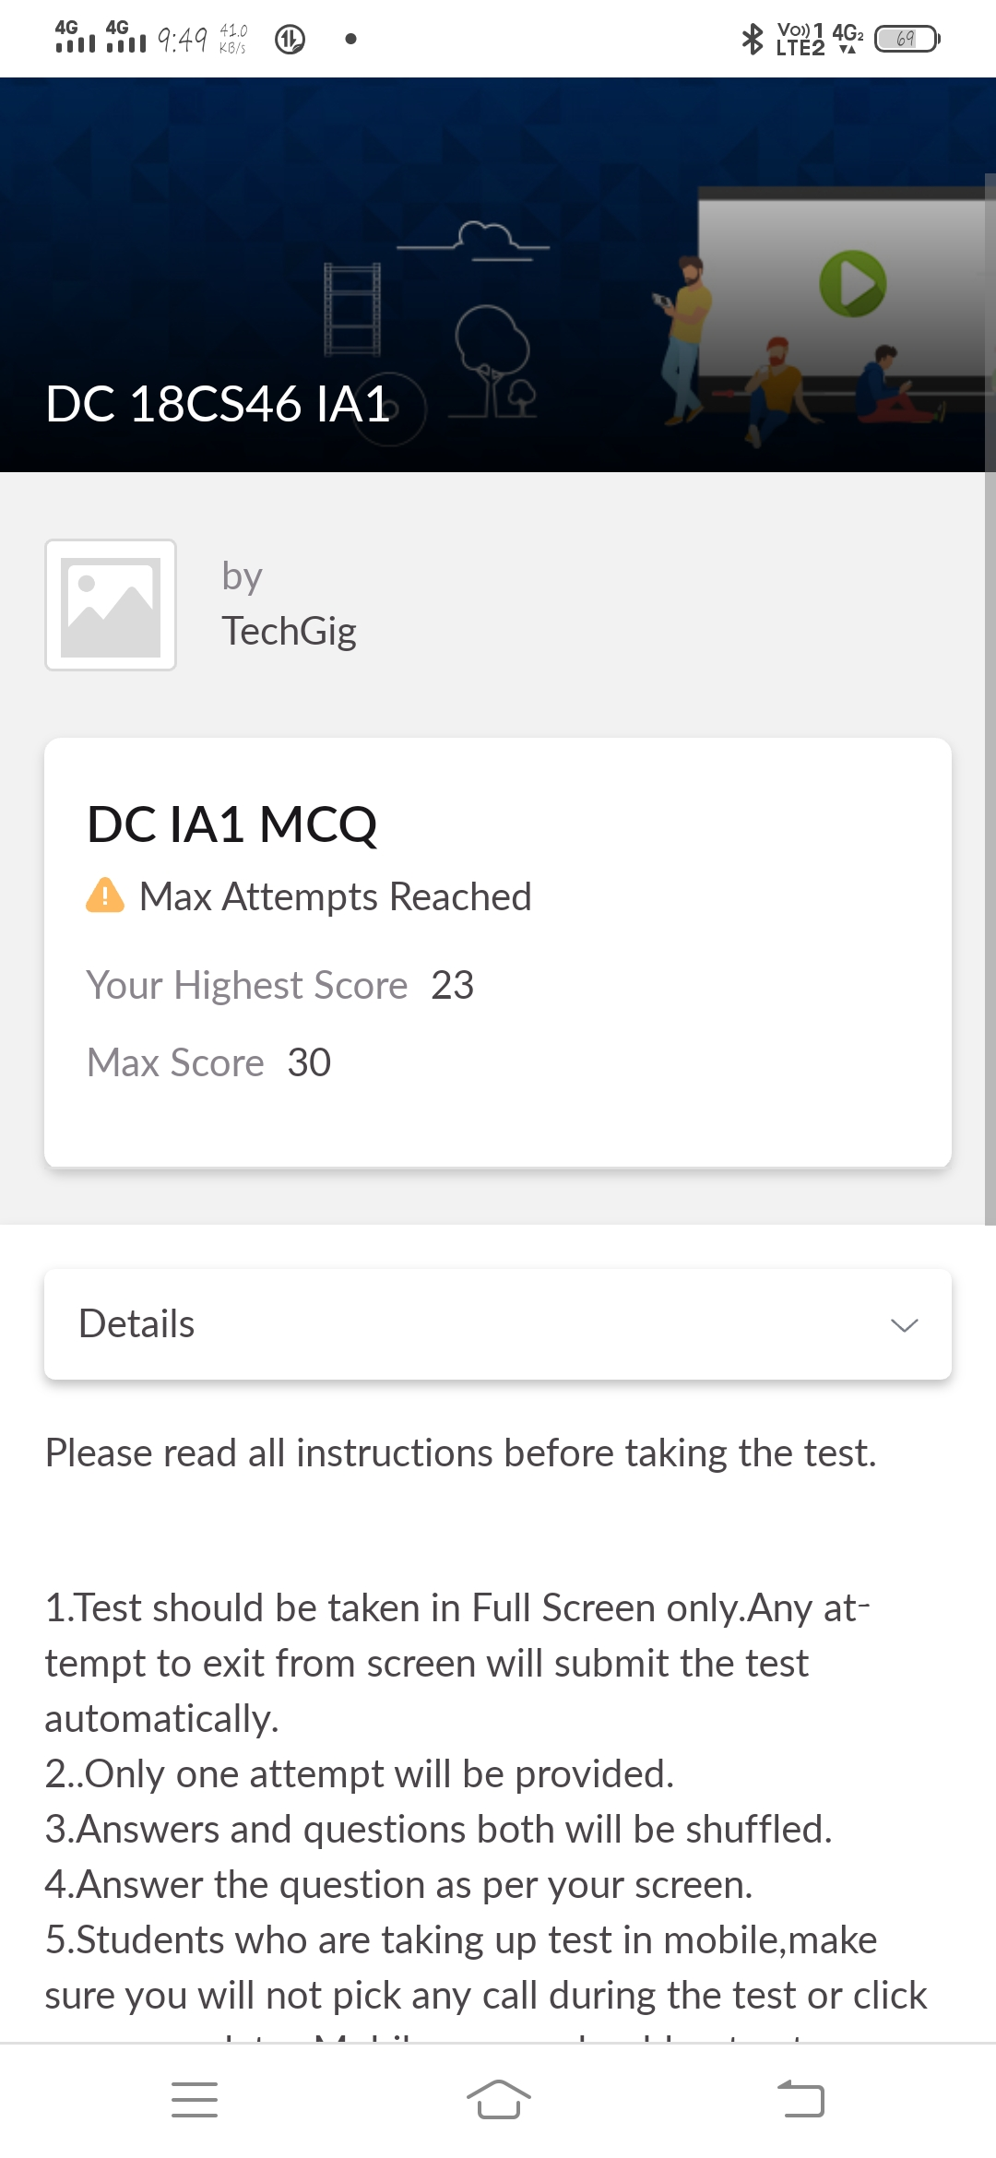

**Certification Course Details:**

**Name of the course**: PYTHON WORKSHOP FOR BEGINEERS

**Certificate Provider**: BrainOVision

the total duration is 2.5 hours.

I have participated in Python workship for begineers which was held on 19 May 2020. and received its certificate.

I learned a lot and look forward to hearing of future workshops.

**The following contents are thought during workshop:**

Basic Discussion on Subject :

Whats Python and its scope in Present and Future

Why we need to go for Python

Internal Concept and Practical Implementation :

Use Python Interpreter and Compiler

Basic Operations and Data Types

Go details in List, Tuple and Dictionary Usage

Code Block and Indentation

Conditions and Iteration

Built Own function and use built-in def

Manage and develop own modules

Manage Exception Handling

File Handling and Operations

Network Program and Socket Implementation

Overview Only :

Overview of Class and Object Oriented Approach

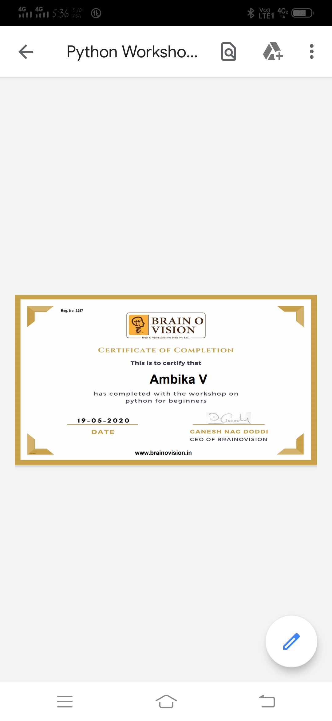

**Name of the course**: CLOUD FOUNDATION

**Certificate Provider**: Greatlearning Academy

the total duration is 4.5 hours.

This certification consist of 11 modules and i started the last module i.e, Summary

Cloud computing facilitates the access of applications and data from any location worldwide and from any device with an internet connection. Cost savings; Cloud computing offers businesses with scalable computing resources hence saving them on the cost of acquiring and maintaining them.

And herby i have completed cloud foundation course and after completeing all modules there was quiz with 10 qu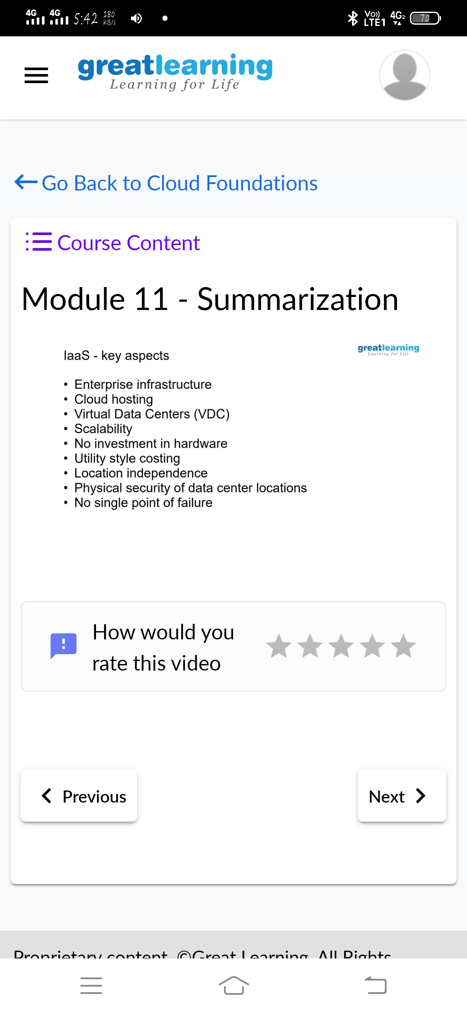estions. After clearing this i got my certificate.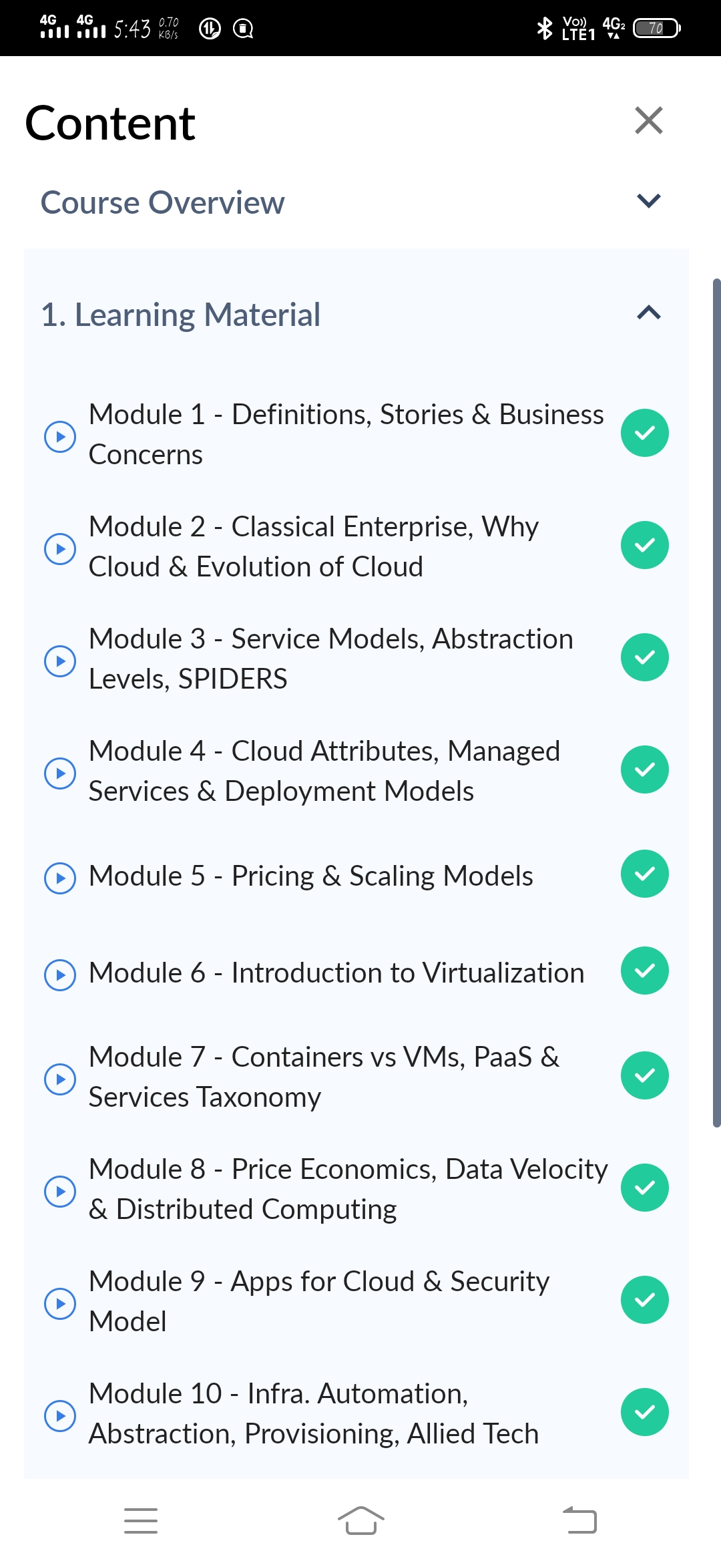

The below is the certificate received from Greatlearning Academy.

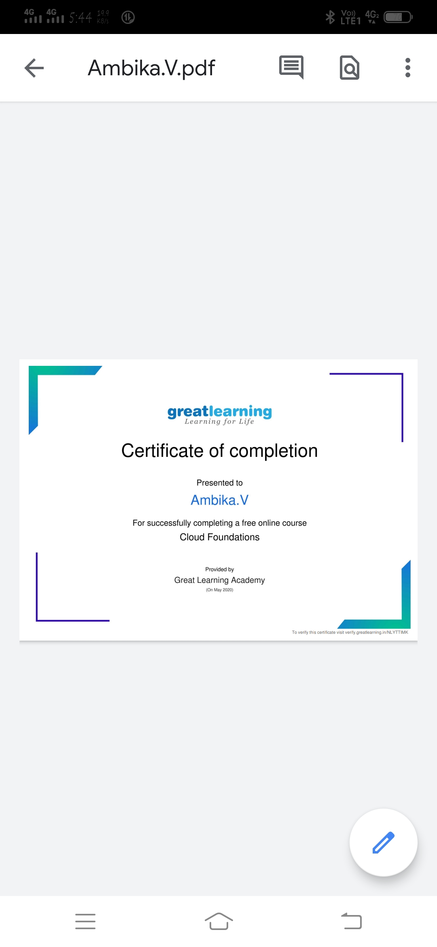

**Poblem Statement:** Write a C or Java program to implement round robin type of process scheduling.

Input: Process with burst time, arrival time and specify the time quantum

Output: Processes scheduled based on the round robin type of scheduling, with its average waiting time.

